1 This project involves using the the Pi SenseHAT Shield and a Python program to recreate the game Rock Paper Scissors, Lizard Spock game invented by internet pioneer Sam Kass and made popular in the Big Bang Theory !.

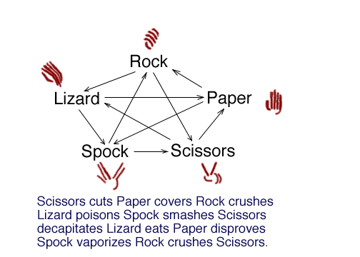

2 The SenseHAT is attached directly to your Pi and uses the LED matrix as a virtual screen, displaying instructions and the associated game images when playing the game.

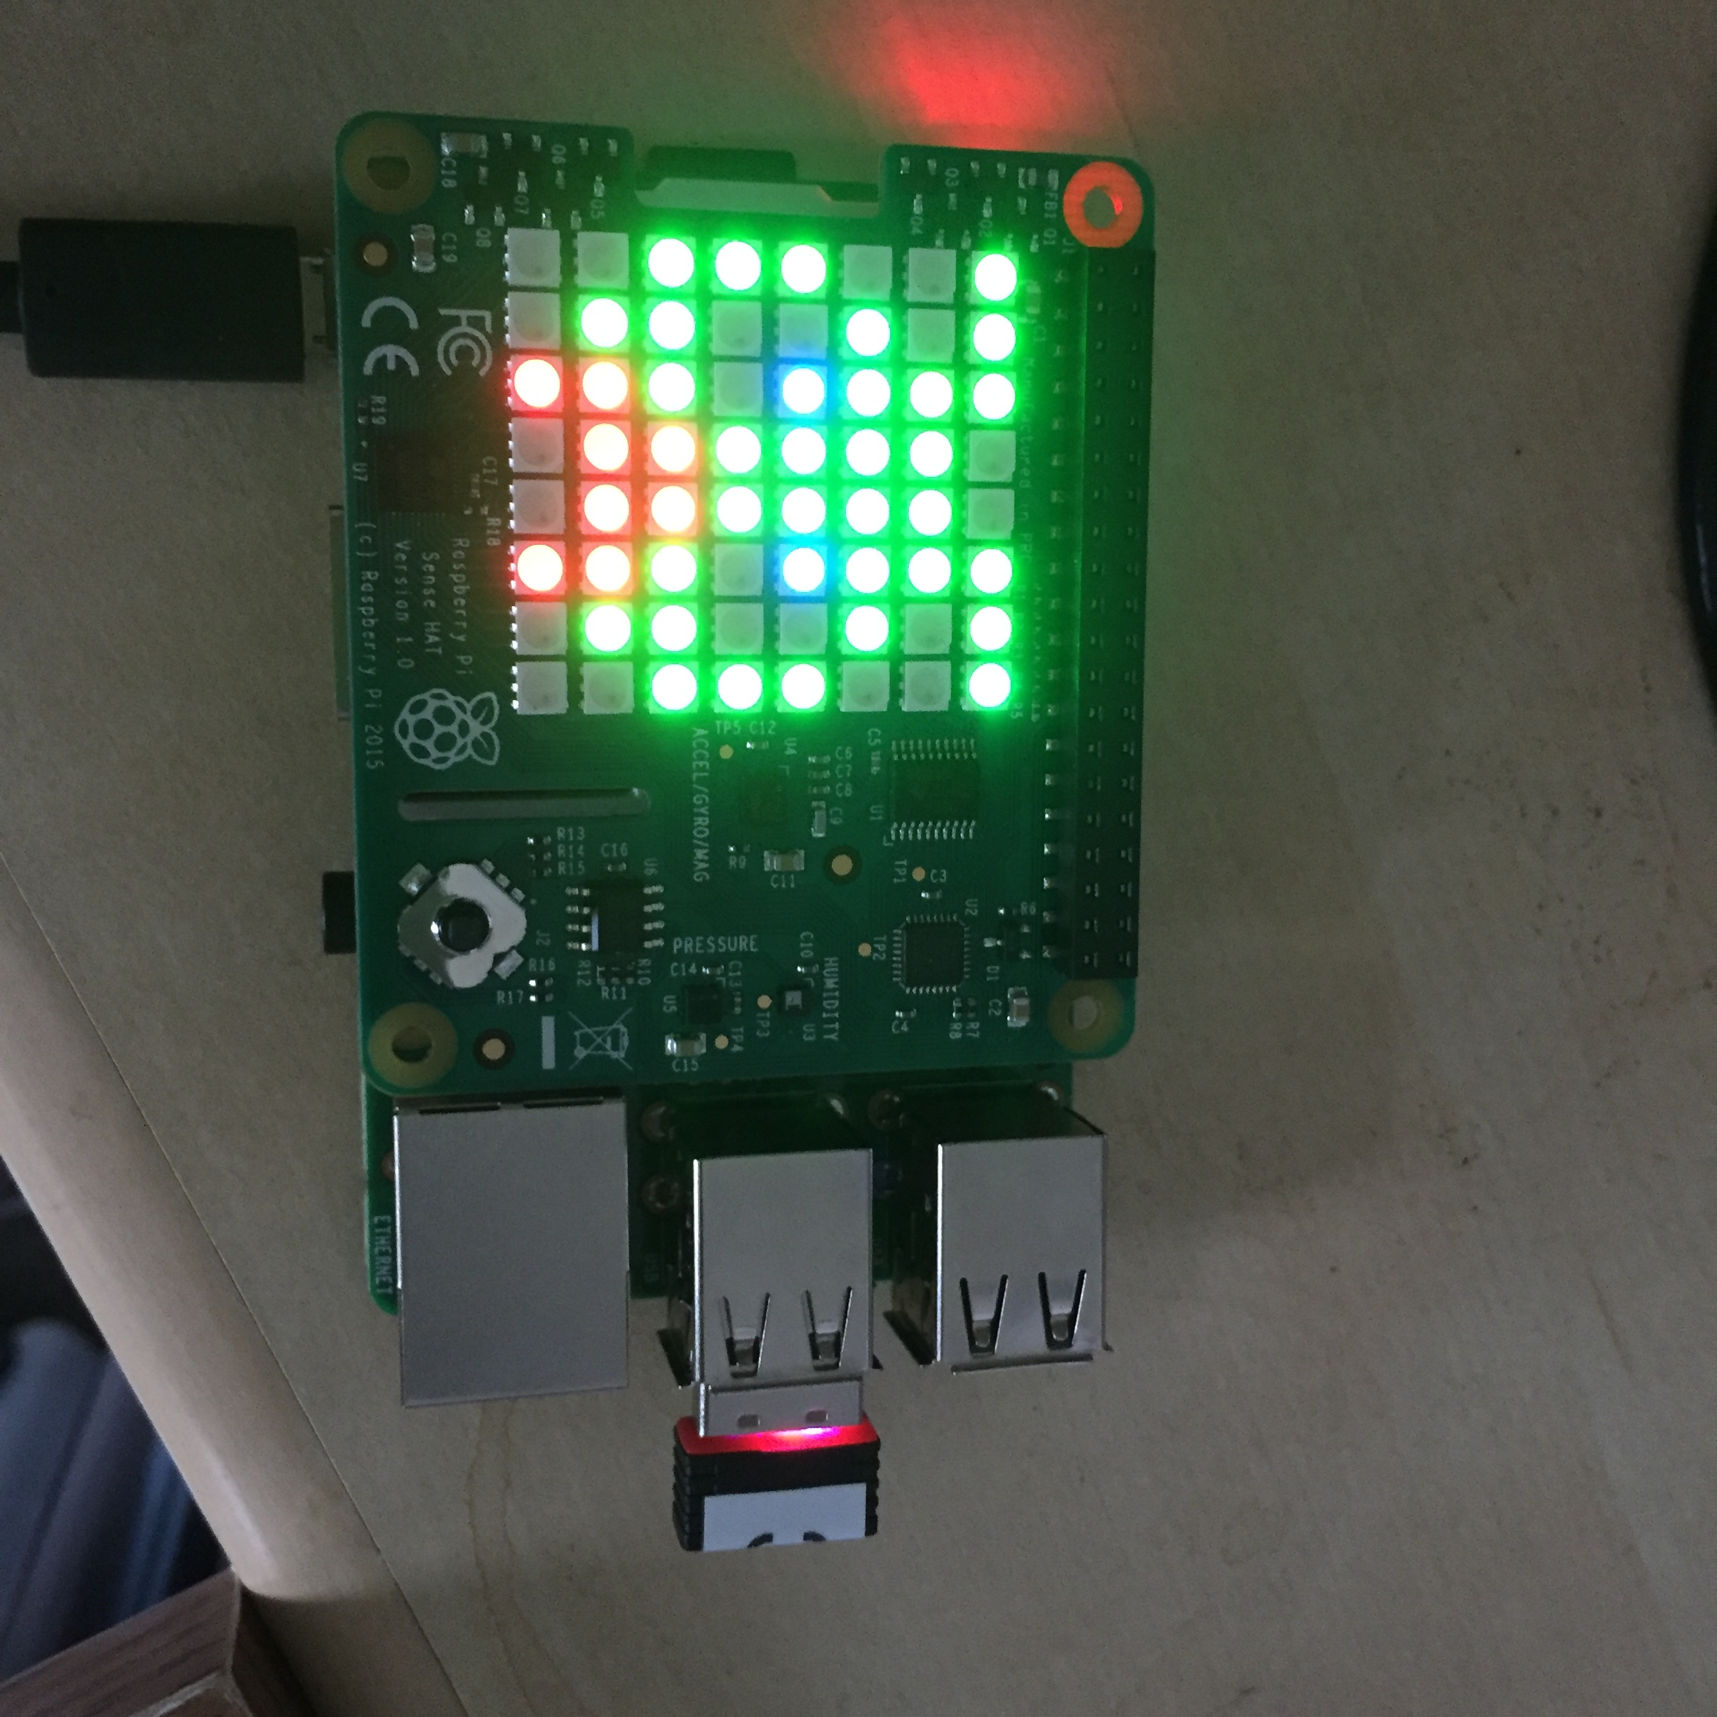

3 The Game Rock Paper Scissors Lizard Spock is a Python program RPSLS.py which uses the pygame and SenseHat library’s to create an extension of the populate Rock Paper Scissors game!

The source RPSLS.py and associated images accompanies this document. Copy these onto your Pi and run the python program from a Terminal Window on your Pi.

4 RPSLS.py is a One Player vs Computer game, each player takes a turn, the Human player scrolls through the five images representing the Rock, Paper, Scissors, Lizard, Spock displayed as 8x8 pixel images on the SenseHAT LED’s using the “load_image” method of the SenseHAT. The computer then makes its choice and the results are compared. The winner is then displayed in the LED using the ‘show_message’ method of the SenseHAT – displayed as scrolling text. The game then repeats.

5 The version with this document has additional comments to explain how the code has been structured.

Take a moment to examine the code for RPSLS.py and note the following:

* Functions are used to split up the logic handling and make the code easier to read
* Numbers represent choices and are converted to Strings for a more readable form
* The images names are aligned to the numbers
* Computer choice is a random selection of the same choices
* There is a splash screen and sensing of key presses make the selections.

5 How you can improve the game, have you got a similar idea that will use the LED’s or other functions of the SenseHAT?

More information on this material can be found at the following sites:

<http://www.samkass.com/theories/RPSSL.html>

<https://www.raspberrypi.org/blog/rock-paper-scissors-lizard-spock/>